Making prisms using Microsoft Word
Experiment with using cubes to making models of different rectangular prisms.
Note: These instructions are designed for Microsoft Word 2016.
- On the Insert tab, select Shapes, Basic Shapes, Cube.
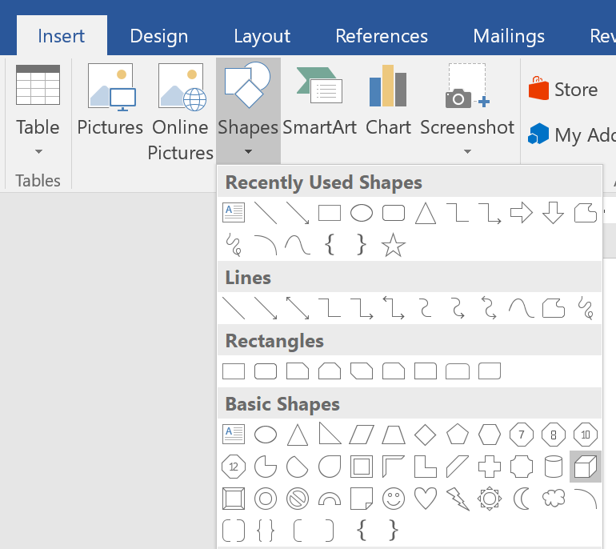
- Click and drag with the mouse to draw the rectangle. Hold the Shift key when drawing to make the shape a square. Click and drag the white handles to resize the cube.
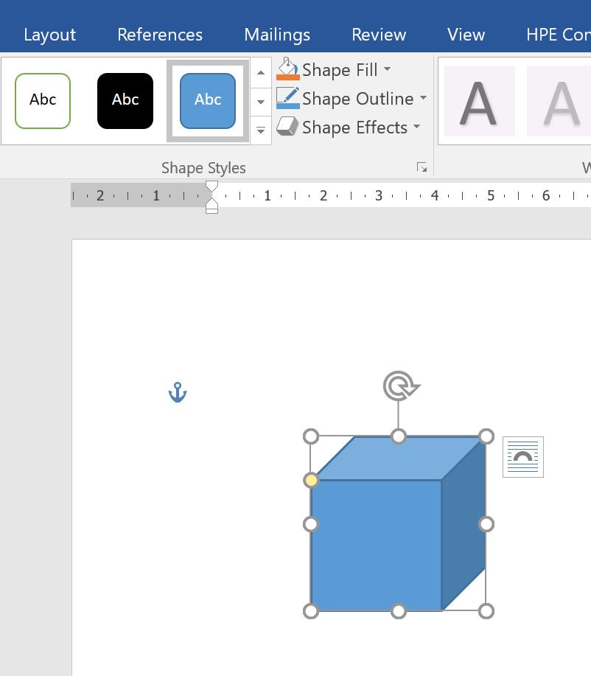
- With the cube selected, open the Drawing Tools tab. Experiment with the Shape Styles tools to find a design that you are happy with. Here are some examples.
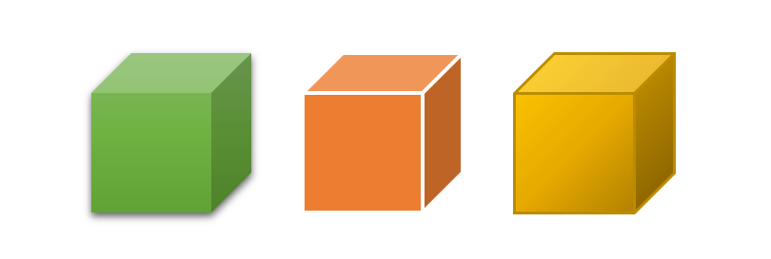
- To start, copy and paste your cube 6 times.
- Arrange the cubes into the following rectangular prism. Use the arrow keys on your keyboard to ‘nudge’ the shapes into alingment.
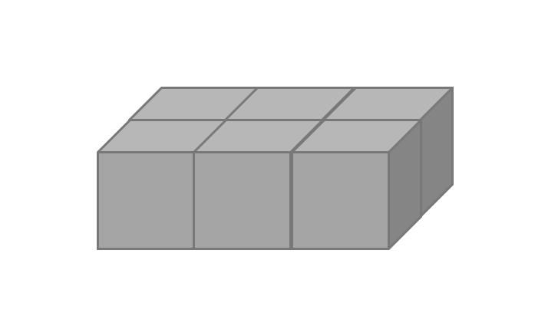
- You can change the ordering of the cubes (to make them appear ‘behind’ others) by right-clicking and selecting Bring to Front or Send to Back.
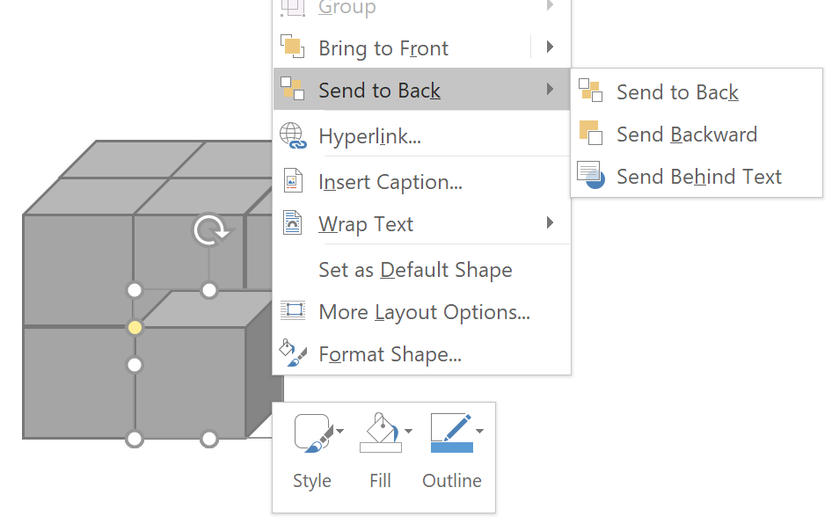
- Consider adding labels for the 3 dimensions – length, width (or depth) and height and then calculate the volume.
In this example, multiply the length (3 units) by the width (2 units) of the base or bottom layer 3 x 2 = 6 cubic units.
Multiply this by the height (2 units) and the volume is 6 x 2 = 12 cubic units.
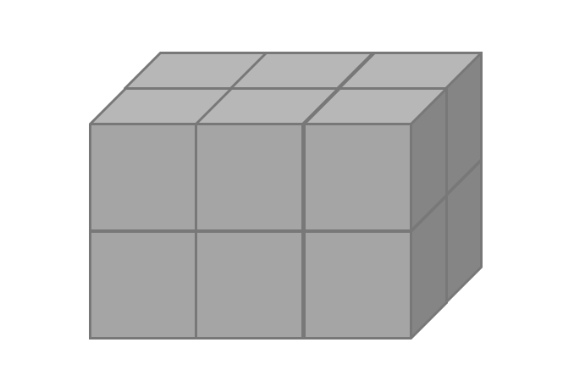
- Create your own prisms using this process and then calculate the volume. You could also challenge your classmates to calculate the volume of your creations.

